### POC 1 ( converting permanent schema into transient schema in permanent DB)

1. **CREATE OR REPLACE DATABASE permanent_db;**
2. **create SCHEMA permanent_db.PERM_SCHEMA**
3. **CREATE OR REPLACE TRANSIENT SCHEMA permanent_db.PERM_SCHEMA**

**CLONE permanent_db.PERM_SCHEMA**

**COMMENT = 'COPYING A PERMANET SCHEMA INTO TRANSIENT';**

1. **SHOW SCHEMAS;**

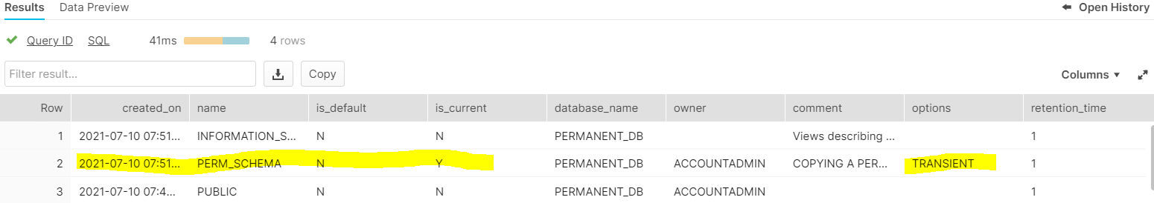

Hence we can do it

When we try to convert transient to permanent we get below error



### POC 2 (what happen to objects when db becomes transient)

1. **Drop database permanent_db**
2. **CREATE OR REPLACE DATABASE permanent_db;**
3. **create SCHEMA permanent_db.sample_permanent_schema**
4. **create table mytable (amount number);**

**insert into mytable values(1);**

1. **Show tables ;**

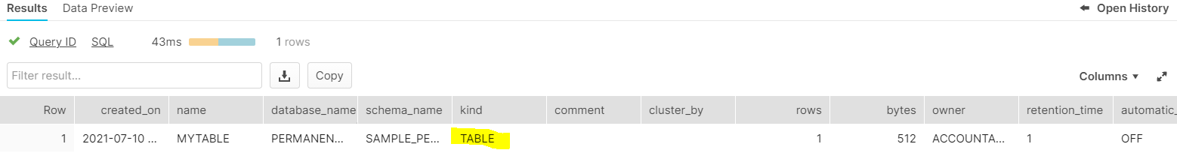

We can see that table is permanent in nature (kind = table)

1. **Show Schemas**

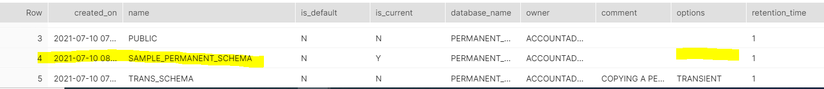

We can see that schema is also permanent in nature

### now converting whole permanent db into transient###

1. **CREATE OR REPLACE TRANSIENT database permanent_db**

**CLONE permanent_db**

1. **Show schemas;**

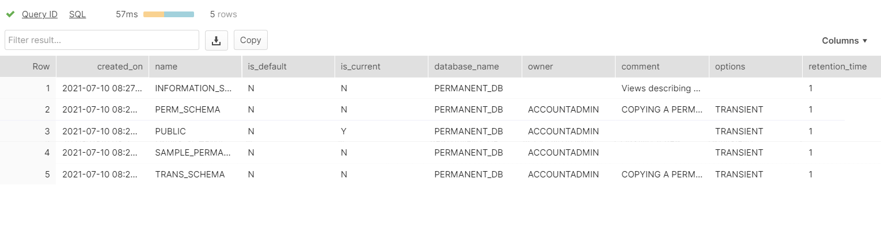

We can see all schemas are become transient in nature.

1. Show tables ;



We can see here that table is being dropped

1. To confirm the existence of table

SELECT * FROM MYTABLE;



Now if create again –

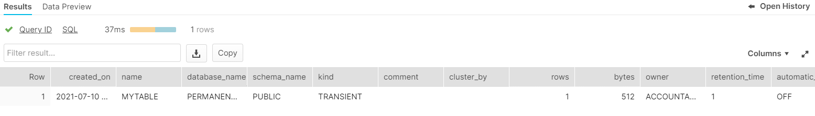

<https://community.snowflake.com/s/question/0D50Z00008UuPJHSA3/transient-schema-is-it-transient>

when we convert schema from perma to transient , table wont become transient or gets lost ( it remains permanent) but when we create a table irrespective transient or not , the table will become transient by default